**Neural Ninjas: *Duality AI Machine Learning Competition Report***

This document outlines the model development and experimentation pipeline followed by Team **Neural Ninjas** during the **Duality AI Machine Learning Competition**. The aim was to iteratively improve object detection performance through model upgrades, hyperparameter tuning, data augmentations, and ensemble techniques. Our final approach combines **YOLOv8 and YOLOv11** with **Non-Maximum Suppression (NMS)** for optimal detection accuracy.

-> Here is a summary of what our team did for the Duality AI – Machine Learning Competition.

The initial code used YoloV3 with 1 epoch and other parameters. We started Hyperparameter tuning from here. Tried YoloV3 with 10, 25, 50, 100 and 250 epochs with different variants of parameters.

Then switched the model to YoloV8n.

Which boosted out mAP @ 50 to 94% of training value. Then tested on the

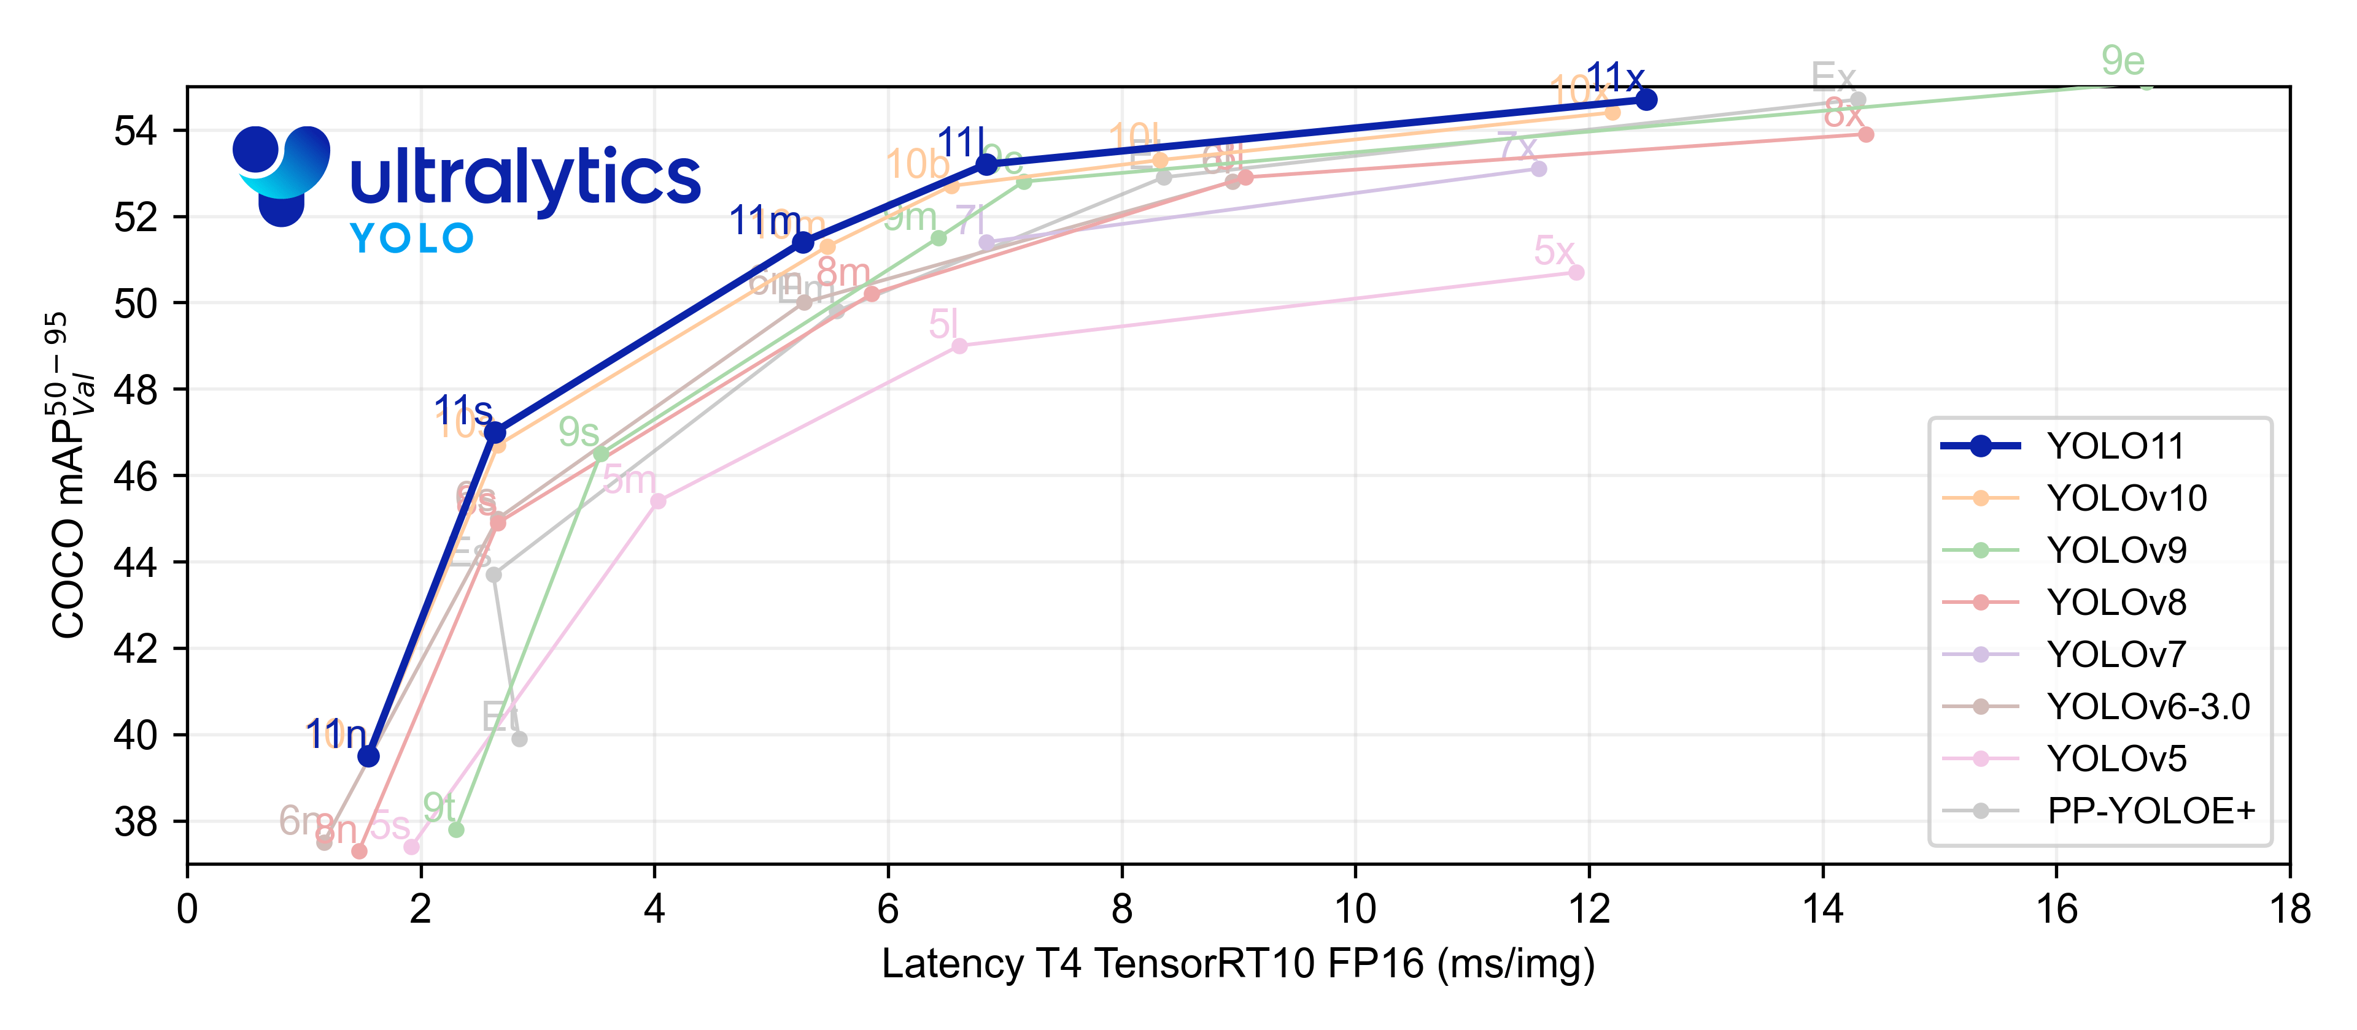

Figure 1: Image source: Ultralytics official

Used Yolov8n and YoloV9 and did non-Maximum suppression. It is kind of an ensemble technique.

Figure 2: YOLO V 11 - 50 epoch

Step-by-Step Pipeline

# 1. Baseline – YOLOv3

* Started with the baseline YOLOv3 model as provided.
* Trained for **1 epoch** with default parameters.

# 2. Hyperparameter Tuning – YOLOv3

* Explored training YOLOv3 with **10, 25, 50, 100, and 250 epochs**.
* Tuned learning rate, batch size, and augmentation strategies.
* **mAP@50:** 0.55

# 3. Data Augmentation

* Applied bounding-box aware augmentations:
  + Horizontal/Vertical Flip
  + Random Rotation & Scaling
  + Mosaic Augmentation
  + Color Jitter & Brightness Shift
* Improved generalization and robustness.

# 4. Model Upgrade: YOLOv5

* Switched to **YOLOv5** for better architecture and speed.
* Used pretrained weights, fine-tuned on our dataset.
* **mAP@50:** 0.66

# 5. Advanced Model: YOLOv8

* Upgraded to **YOLOv8n** (Ultralytics).
* Notable performance boost in accuracy and speed.
* Trained for multiple epochs with tuned batch size.
* **mAP@50:** 0.854

# 6. Experimental Model: YOLOv11

* Integrated **YOLOv11**, a cutting-edge variant.
* Trained for **50 epochs** using optimized training parameters.
* Showed the highest standalone performance.
* **mAP@50:** 0.8504

# 7. Ensemble Strategy: YOLOv8 + YOLOv11

* Applied **Non-Maximum Suppression (NMS)** to ensemble predictions.
* Combined bounding box predictions from YOLOv8 and YOLOv11.
* Resulted in enhanced precision and reduced false positives.
* **mAP@50:** 0.95

Graphs for this Ensemble Method

ON Testing set

